NSW Housing Affordability & Rental Stress Analytics Platform

Power BI Data Model Documentation

1. Introduction
The Power BI semantic model supporting the NSW Housing Affordability & Rental Stress Analytics Platform integrates property sales, rental market activity, Census-based household characteristics, geographic information and forward-looking housing scenarios.
The model is designed to support analysis at multiple levels of granularity, including:
- SA4 region
- Postcode and suburb
- Dwelling type
- Bedroom count
- Historical quarter
- Forecast scenario and future quarter
The historical component of the model follows a fact-constellation architecture, where several independent rental and sales fact tables share common geography and time dimensions.
Two tables provide the main filtering framework for the historical model:
- postcode_dim — geographic filtering
- Date_Dim — historical time filtering
The individual sales and rental tables are intentionally maintained separately because they operate at different levels of detail. Instead of creating direct fact-to-fact relationships, the shared dimensions allow the datasets to be analysed consistently while preserving their original analytical grain.
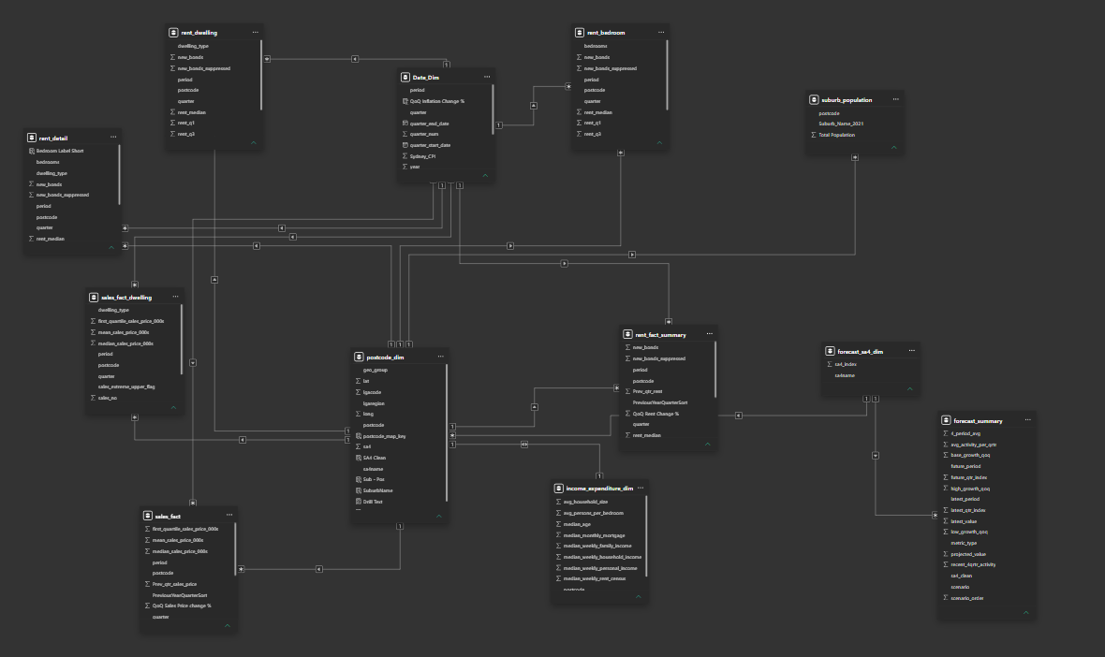
Overall Model View
The forecasting component operates separately at SA4 level and uses forecast_sa4_dim to connect regional forecasts with the postcode-based historical model.

2. Core Geographic and Time Dimensions

2.1 postcode_dim
postcode_dim is the primary geographic dimension of the historical model.
It provides a consistent geographic reference for the sales, rental and affordability datasets and supports filtering from broad Sydney regions down to individual postcodes and suburbs.
The table primarily contains geographic information such as:
- Postcode
- Suburb name
- SA4 region
- LGA or regional classification
- Broader geographic grouping
- Latitude and longitude
- Cleaned geographic identifiers
- Mapping keys used in Power BI geographic visuals
The primary grain of the table is effectively:
One geographic record per postcode.
This makes postcode_dim the central geographic filtering table used throughout the reporting solution.
Relationships
postcode_dim is positioned on the one-side of one-to-many relationships with the major historical fact tables.
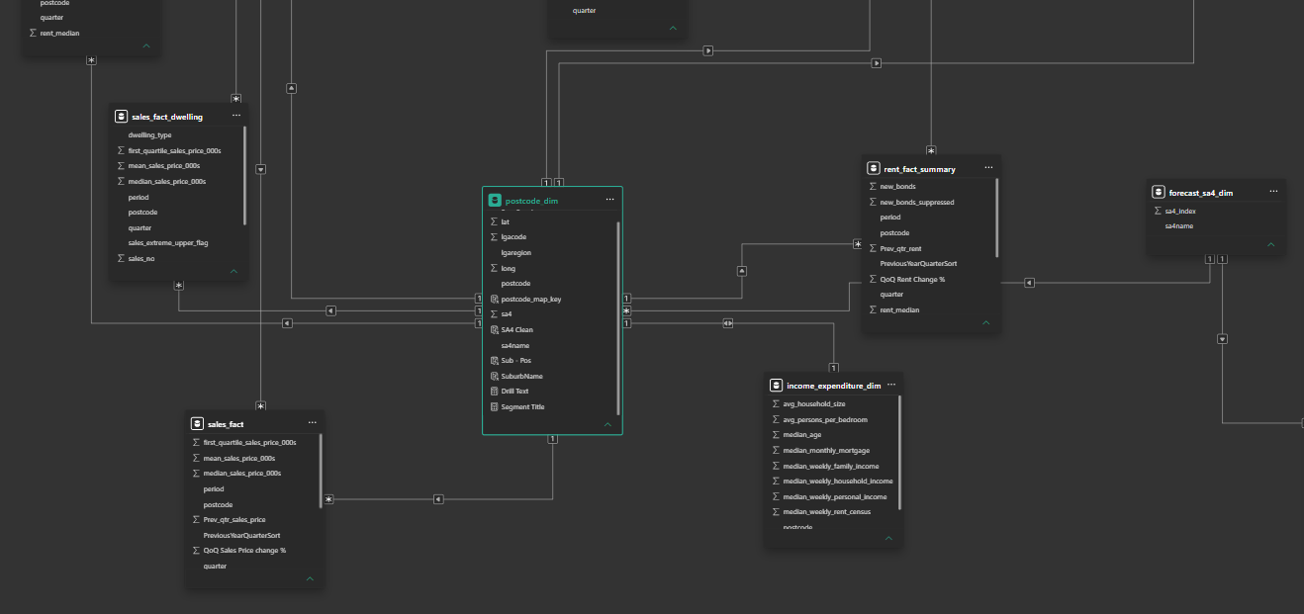
Postcode_dim table relationships with other fact and dimension tables
When a user selects a postcode, suburb, SA4 or another geographic category from postcode_dim, that filter propagates to the relevant rental and sales records.
An important feature of the model is that the sales and rental fact tables are not directly connected to one another. Instead, they are analysed through their common geographic dimension.
This helps avoid ambiguous fact-to-fact filtering and allows datasets with different grains to remain independent.

2.2 Date_Dim
Date_Dim acts as the central historical time dimension.
It provides a consistent quarterly time structure for historical sales and rental analysis.
The table contains fields such as:
- Reporting period
- Year
- Quarter
- Quarter number
- Quarter start date
- Quarter end date
- Sydney CPI and inflation-related attributes
The model primarily operates at quarterly frequency, allowing the same period selection to be applied consistently across the historical housing datasets.
Relationships
Date_Dim sits on the one-side of one-to-many relationships with the historical rental and sales tables.
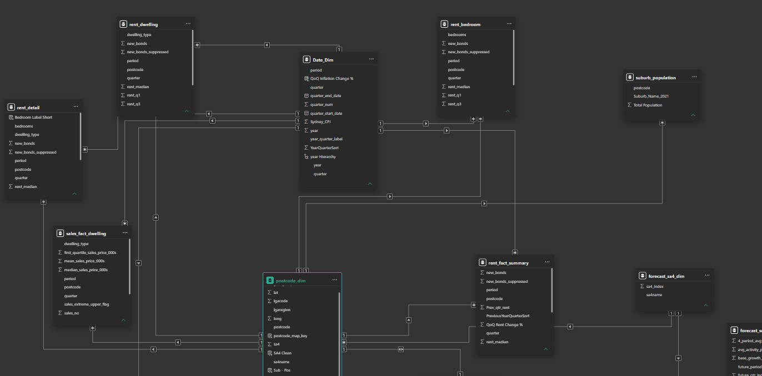
Date_Dim table and its relationship with other dimension and fact tables
For example, selecting 2025-Q3 from Date_Dim filters the corresponding quarter in the relevant sales and rental tables simultaneously.
Together, postcode_dim and Date_Dim operate as the two main conformed dimensions of the historical model.
They allow different fact tables to be compared under a common:
- geographic context; and
- reporting-period context.

3. Rental Summary and Segment Tables
The rental component of the model uses several tables representing the rental market at different levels of detail.
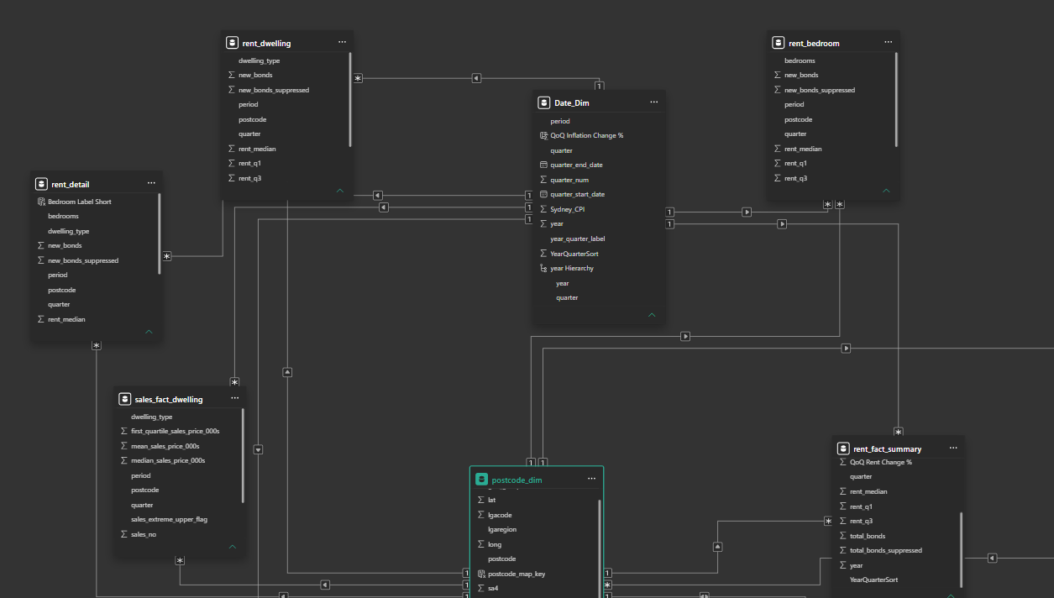
All 4 Rental fact tables and their relationships with the dimension tables
This structure allows high-level postcode rental conditions to be analysed alongside more detailed dwelling-type and bedroom-level patterns without forcing all rental information into a single table.

3.1 rent_fact_summary
rent_fact_summary is the main postcode-level rental summary table.
Its grain is:
Postcode × Reporting Period
There is one record for each postcode and quarter.
The table primarily contains:
- Median weekly rent
- Number of new rental bonds
- Total rental bonds
- Suppression indicators
- Quarter and period information
- Previous-period or rental-change fields
Because there is one row per postcode and period, this table is particularly suitable for regional and suburb-level measures such as:
- Median weekly rent
- Total new bonds
- Total overall bonds
- Rental growth
- Rental market activity
- Rent-based affordability calculations
For example:
Total New Bonds =
SUM(rent_fact_summary[new_bonds])
can aggregate reported new bonds from postcode level to SA4 level while respecting the selected reporting period.
Likewise:
Total Overall Bonds =
SUM(rent_fact_summary[total_bonds])
provides the reported bond stock within the selected geographic and quarterly context.
rent_fact_summary therefore acts as the primary rental fact table when a dwelling-type or bedroom-level breakdown is not required.

3.2 rent_dwelling
rent_dwelling extends the rental dataset by introducing dwelling type.
Its conceptual grain is:
Postcode × Reporting Period × Dwelling Type
The table contains rental information for different property categories, such as:
- House
- Flat or unit
- Townhouse
- Other available dwelling classifications
It primarily includes:
- Median rent
- Rental quartiles
- New bond activity
- Suppression information
- Postcode
- Period
- Dwelling type
This table supports questions such as:
Are houses experiencing greater rental pressure than flats or units within the same region?
It is therefore an important source for the Segment Drivers section of the Power BI report.

3.3 rent_bedroom
rent_bedroom provides a rental breakdown based on number of bedrooms.
Its conceptual grain is:
Postcode × Reporting Period × Bedroom Category
The table contains measures such as:
- Median rent
- First and third rent quartiles
- New rental bonds
- Suppression indicators
- Bedroom category
- Postcode and reporting period
This enables comparison of rental-market behaviour between categories such as:
- 1-bedroom properties
- 2-bedroom properties
- 3-bedroom properties
- 4-bedroom properties
- Other available bedroom classifications
This table is useful for identifying whether rental affordability pressure is concentrated within particular bedroom configurations.
3.4 rent_detail
rent_detail provides the most granular rental segmentation within the model.
Unlike rent_dwelling and rent_bedroom, which analyse one segment dimension at a time, rent_detail contains both:
- Dwelling type
- Bedroom count
Its conceptual grain is therefore approximately:
Postcode × Reporting Period × Dwelling Type × Bedroom Category
This enables more detailed analysis of combinations such as:
- 2-bedroom flats
- 3-bedroom houses
- 4-bedroom houses
- Other dwelling-bedroom configurations
The table also contains rental measures such as:
- Median rent
- New bonds
- Suppression indicators
It is used where the analytical requirement needs more detailed housing-segment information than the standalone dwelling or bedroom tables provide.
3.5 Relationships Between the Rental Tables
The rental tables are not directly related to one another.
Instead, each table is independently connected to the shared geographic and time dimensions.
Additional detailed rental analysis:
Date_Dim + postcode_dim → rent_detail
This architecture is important because each rental table operates at a different grain.
For example, directly joining a postcode-quarter summary table to a postcode-quarter-dwelling-bedroom table could duplicate rows or create ambiguous filtering.
Maintaining the tables independently allows DAX measures and Power BI visuals to use the appropriate source table for each analysis.

An example is the dynamic segment-level bond measure:
Seg Reported New Bonds =
VAR BedroomView =
ISINSCOPE(rent_detail[bedrooms])

VAR DwellingView =
ISINSCOPE(rent_dwelling[dwelling_type])

RETURN
SWITCH(
TRUE(),

BedroomView,
CALCULATE(
SUM(rent_detail[new_bonds]),
NOT ISBLANK(rent_detail[new_bonds])
),

DwellingView,
CALCULATE(
SUM(rent_dwelling[new_bonds]),
NOT ISBLANK(rent_dwelling[new_bonds])
),

BLANK()
)
The measure dynamically selects the appropriate rental source depending on whether the report visual is analysing bedroom count or dwelling type.

4. Sales Tables
The sales component follows a similar structure to the rental model.
Separate tables are maintained for general postcode-level sales analysis and dwelling-type-specific sales analysis.
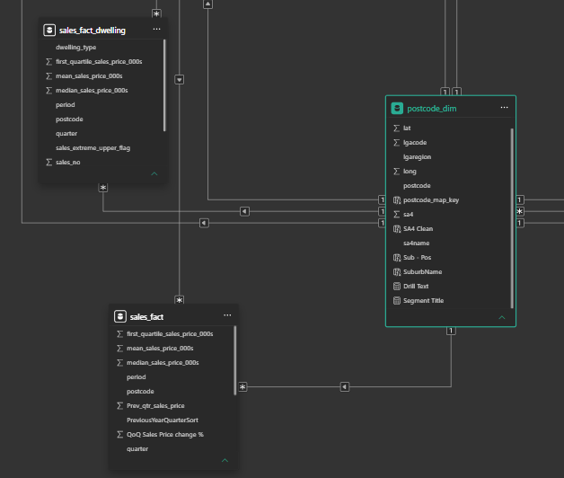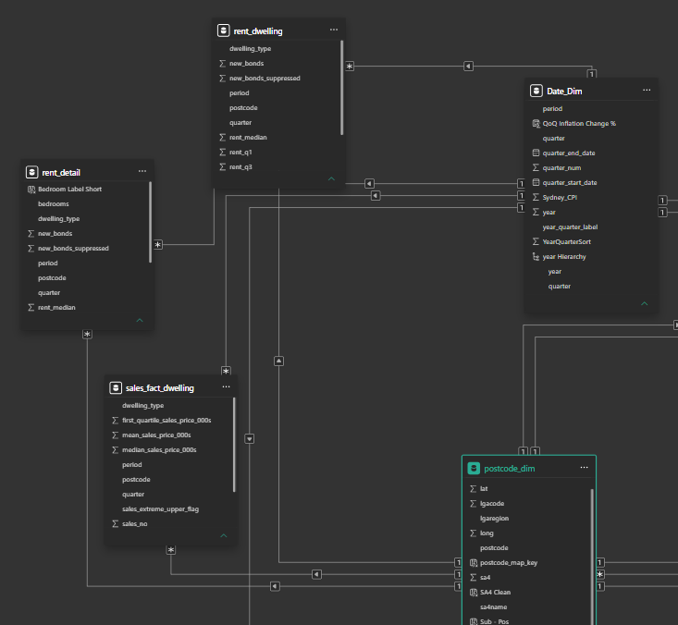
Relationship b/w sales tables with the main dimension tables

4.1 sales_fact
sales_fact is the main historical property-sales table.
Its primary analytical grain is:
Postcode × Reporting Period
The table contains core property-market indicators including:
- Median sales price
- Mean sales price
- First-quartile sales price
- Number of property sales
- Previous-period sales price information
- Sales-price change calculations
- Quarter and period identifiers
It supports the principal property-market analysis in the report, including:
- Median property price
- Sales transaction activity
- Quarter-over-quarter price movement
- Long-term sales-price growth
- Growth versus volatility
- Purchase affordability
- Price-to-income analysis

4.2 sales_fact_dwelling
sales_fact_dwelling introduces a dwelling-type breakdown to the sales dataset.
Its conceptual grain is:
Postcode × Reporting Period × Dwelling Type
The table contains property-price measures and sales activity separately for different dwelling categories.
It includes information such as:
- Median sales price
- Mean sales price
- Sales price quartiles
- Number of sales
- Dwelling type
- Extreme-price or quality-related flags
- Period and postcode
The table allows the sales market to be analysed at a more detailed housing-segment level when required.

4.3 Relationships Between the Sales Tables
Both sales tables connect independently to the common geographic and time dimensions.
Conceptually:
Date_Dim
│
┌──────┴──────┐
▼ ▼
sales_fact sales_fact_dwelling
▲ ▲
└──────┬──────┘
│
postcode_dim
The general relationship structure is:
Date_Dim (1) → (*) Sales Fact Table
postcode_dim (1) → (*) Sales Fact Table
The two sales tables are not required to filter one another directly.
Instead, the shared dimensions provide the common analytical context.

4.4 Relationship Between Sales and Rental Data
There is no direct relationship between the sales and rental fact tables.
Instead, both groups are filtered through:
- postcode_dim
- Date_Dim

Conceptually:
Date_Dim
│
┌─────────┴─────────┐
▼ ▼
Sales Facts Rental Facts
▲ ▲
└─────────┬─────────┘
│
postcode_dim
This architecture allows measures from different markets to be compared within the same filter context.
For example, the model can compare:
- Sales growth versus rent growth
- Median sales price versus median weekly rent
- Sales activity versus rental activity
- Purchase pressure versus rental pressure
without creating a direct physical relationship between fact tables of different granularities.

5. income_expenditure_dim
income_expenditure_dim provides the household, income and socioeconomic information required to convert housing-market values into measures of affordability pressure.
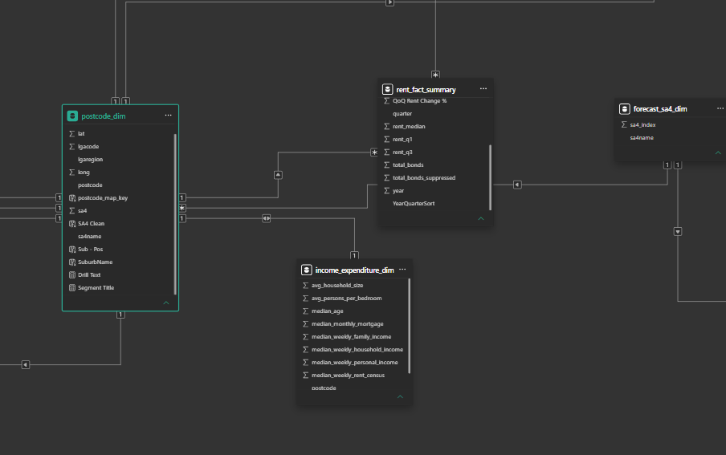
Income_expenditure_dim
Unlike the sales and rental tables, this table does not contain quarterly housing-market observations.
Instead, it provides a postcode-level Census-based socioeconomic reference.
The table primarily contains variables such as:
- Median weekly household income
- Median weekly family income
- Median weekly personal income
- Median monthly mortgage
- Average household size
- Average persons per bedroom
- Median age
- Census-based rental and household indicators
The table therefore provides the denominator or household context for several affordability calculations.

5.1 Relationship with postcode_dim
The model shows income_expenditure_dim connected directly to postcode_dim through a one-to-one geographic relationship.
Conceptually:
postcode_dim (1) ◄────► (1) income_expenditure_dim
This allows the Census-based socioeconomic information to participate in the same geographic filtering system used by the sales and rental datasets.
For example:
SA4 selected
↓
postcode_dim
↓
Postcodes belonging to selected SA4
↓
income_expenditure_dim
The relevant postcode-level income values can then be used alongside rental and sales measures.

5.2 Use in Affordability Calculations
The income table enables measures such as Price-to-Income Ratio.
Conceptually:
Median Sales Price
÷
Median Annual Household Income
=
Price-to-Income Ratio
Annual income can be derived from Census weekly household income:
Median Weekly Household Income × 52

The table is also used to calculate rental burden:
Median Weekly Rent
÷
Median Weekly Household Income
=
Rent Burden %
This allows nominal housing costs to be converted into metrics that represent their magnitude relative to household financial capacity.

5.3 Interpretation of the Income Data
The income data acts as a fixed Census affordability baseline rather than a quarterly income series.
Historical rental and sales values change between quarters, while the Census household-income component remains fixed.
This means measures such as:
- Rent Burden %
- Price-to-Income Ratio
should be interpreted as housing-market pressure relative to the available Census income baseline rather than as estimates using contemporaneous household income for every quarter.
This limitation is documented explicitly in the project to avoid overstating the precision of the affordability measures.

6. Forecast Model
The forecasting component of the semantic model is intentionally separated from the historical postcode-level model.
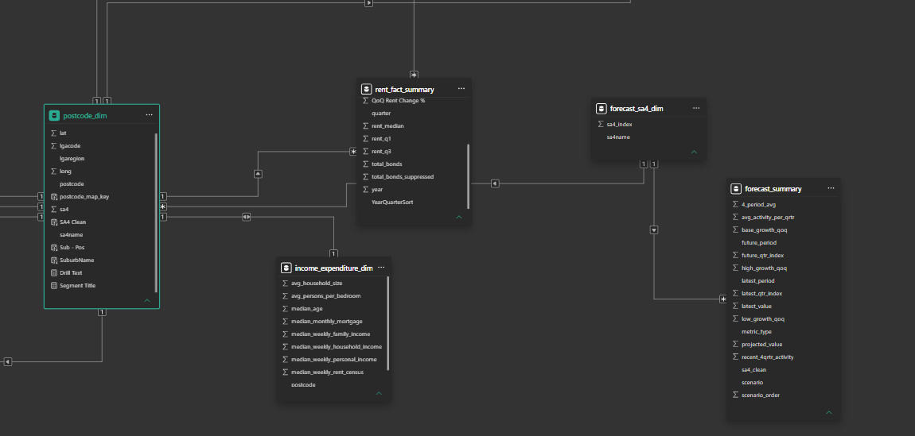
Historical rental and sales analysis primarily operates at postcode level, whereas the forecast output is generated at SA4 regional level.
Two tables support this section:
- forecast_sa4_dim
- forecast_summary

6.1 forecast_sa4_dim
forecast_sa4_dim is the regional geographic dimension used by the forecasting component.
It primarily contains:
- SA4 name
- SA4 index or regional identifier
Each SA4 region is represented once.
The table serves two important purposes:
- It filters the forecast output stored in forecast_summary.
- It connects the regional forecast structure with the postcode-level historical model.

6.2 forecast_summary
forecast_summary stores the output of the project's forward-looking scenario analysis.
Unlike the historical fact tables, which are primarily organised around postcode and historical quarter, this table is structured around:
- SA4 region
- Future reporting period
- Metric type
- Scenario
Its conceptual grain is approximately:
SA4 × Future Period × Metric Type × Scenario
The table contains fields relating to:
- Future period
- Latest historical period
- Latest observed value
- Projected value
- Metric type
- Scenario
- Scenario order
- Low-growth assumption
- Base-growth assumption
- High-growth assumption
- Recent four-quarter activity
- Historical average activity
The table supports separate projected outcomes for rental and property-sales metrics.

6.3 Forecast Scenario Structure
The forecasting framework uses three scenarios:
Low Scenario
Represents a weaker-growth trajectory derived from the lower portion of the historical quarterly growth distribution.
Base Scenario
Represents the central scenario and combines recent market behaviour with longer-term historical behaviour.
High Scenario
Represents a stronger-growth trajectory based on the upper portion of the historical quarterly growth distribution.
The scenario structure is intended to provide a range of plausible housing-market paths rather than a single deterministic prediction.
The forecast output can subsequently be translated into affordability indicators such as:
- Projected sales price
- Projected weekly rent
- Projected price-to-income ratio
- Projected rental burden
- Dual purchase-and-rental pressure

7. Relationships in the Forecast Model
forecast_sa4_dim sits on the one-side of the relationship with forecast_summary.
Conceptually:
forecast_sa4_dim (1)
│
▼
forecast_summary (*)
One SA4 region can therefore contain multiple forecast records corresponding to combinations of:
- Future period
- Metric
- Scenario

For example:
North Sydney and Hornsby
↓
2026-Q1
↓
Rent
↓
Base Scenario
↓
Projected Weekly Rent
represents one forecast observation.

7.1 Connection Between Forecast and Historical Geography
The model also connects forecast_sa4_dim with postcode_dim.
Because one SA4 contains multiple postcodes, the relationship conceptually represents:
forecast_sa4_dim (1)
│
▼
postcode_dim (*)
This creates a bridge between the regional forecast model and the postcode-level historical model.
This allows an SA4 selected in the forecast section to identify the corresponding postcodes in the historical model and therefore provide historical context for:
- Sales conditions
- Rental conditions
- Household income
- Affordability
- Market activity

7.2 Forecast Time Structure
forecast_summary is not dependent on the historical Date_Dim for its future reporting periods.
Instead, the forecast table contains its own future-period fields.
This separation is useful because:
- Date_Dim represents observed historical quarters.
- forecast_summary represents future scenario periods.
The design avoids mixing observed and projected periods within the same historical date dimension.

8. Overall Data Model Architecture
The model architecture can be divided into four logical layers.
- Historical Geography and Time Layer
postcode_dim and Date_Dim provide consistent geographic and temporal filtering.
- Housing Market Fact Layer
Independent rent and sales fact tables retain the appropriate grain required for postcode, dwelling-type and bedroom-level analysis.
- Affordability Context Layer
income_expenditure_dim introduces household income and demographic information that enables nominal rents and property prices to be translated into affordability indicators.
- Forecast Layer
forecast_sa4_dim and forecast_summary provide SA4-level Low, Base and High forward scenarios while maintaining a connection with the historical postcode model.

10. Summary
The Power BI data model is designed around the separation of geography, time, market facts, socioeconomic context and forecast outputs.
postcode_dim and Date_Dim provide the common filtering framework for historical analysis. Rental and sales datasets remain as independent fact tables at their respective levels of detail, allowing postcode, dwelling-type and bedroom-level analysis without creating unnecessary fact-to-fact relationships.
income_expenditure_dim supplements the market data with Census household characteristics, allowing property prices and rents to be interpreted relative to household income rather than only as nominal market values.
The forecast architecture is maintained separately at SA4 level through forecast_sa4_dim and forecast_summary, enabling scenario-based future analysis while preserving a connection to the historical geographic model.
Overall, the model can be described as:
A fact-constellation Power BI semantic model in which shared postcode and quarterly dimensions provide consistent filtering across independent sales and rental datasets of different granularities. Census-based household information is integrated at postcode level to derive affordability measures, while a dedicated SA4 dimension connects the historical housing model with an SA4-level scenario forecasting layer. This structure preserves the analytical grain of each source while supporting regional, suburb-level, segment-level and forward-looking housing affordability analysis.

